Lisa chen

Homework 10

1. Write a fairly complex sentence. The sentence should have at least 12 tokens. More points are awarded for sentences with more than one clause

Riz murdered kalvaxus as he swore profusely, because they were angry about his letters.

1. Hand draw (no copy/paste) a PSG tree of the sentence, labeling POS. Briefly define all phrase terms that appear such as: S, SBAR, NP, VP, PP, etc. This resource may be helpful: <https://gist.github.com/nlothian/9240750>

S: a simple declarative clause

NP: a noun phrase

VP: a verb phrase

SBAR: a clause introduced by a maybe empty subordinating conjunction

ADVP: a adverb phrase

ADJP: a adjective phrase

PP: a prepositional phrase

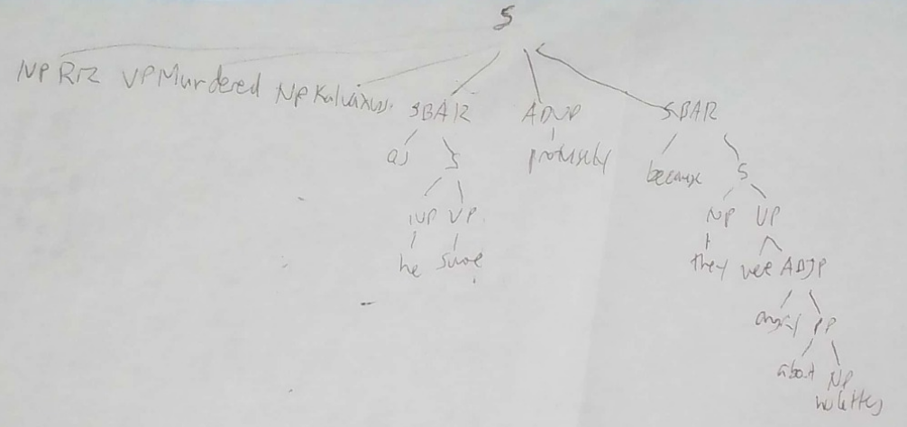

1. Hand draw (no copy/paste) a dependency parse of the sentence, labeling dependency relations (but not POS). Briefly define all dependency relations that occurred in the parse. You can use the Stanford Dependencies Manual

Nsubj: a noun phrase which is the syntactic subject of a clause

Obj: a object

Advcl: a adverbial clause modifier

Mark: the word introducing a finite clause subordinate to another clause

Advmod: a adverb or adverb-headed phrase that serves to modify the meaning of the word

Cop: the relation between the complement of a copular verb and the copular verb

1. For the SRL parse, list the predicate, all arguments (numbered) and modifiers (TMP, LOC, etc.) for each verb in the sentence. Briefly discuss the numbered arguments and their relation to each verb. List each modifier and briefly define what it is. Refer to the list of arguments in the class slides.

Murdered: riz (argument 0) kalvaxus (argument 1) as he swore profusely (adverbial modifier), because they were angry about his letters (cause modifier). The numbered arguments relation with their verb is that riz the one murdering kalvaxus. The adverbial modifier is for when for syntactic elements which clearly modify the event structure of the verb. The cause modifier is for a when an element is reason for action.

Swore: he (argument 0), profusely (manner modifier). The arguments relation with the verb is that kalvaxus is the one swearing profusely. The modifier is for when a element is for how the action was performed.

Were: they (argument 1) angry about his letters (argument 2). The arguments relations with their verb is that riz is the one was angry about his letters.

1. Write a paragraph briefly summarizing the pros/cons of each parse type (your opinion) for your sample sentence

The pro of using PSG easier to read. However, the con of psg is that it’s complex. The pro of using dependency is that root is easier to find. The con of using dependency is that it’s more work to write out. The pro of using SRL it’s easier to categorize things. The con of using SRL is that there’s more things to find.